**NAME: T. J. Pharos Sophy Samuel**

**REG. NO.: 20BAI1049**

**J-Component**

**TITLE: Credit Card Fraud Detection on Imbalanced data**

**Abstract:**

Credit card fraud poses a significant threat to financial institutions and cardholders worldwide. Detecting fraudulent transactions in credit card data is a challenging task, particularly due to the highly imbalanced nature of the data, where the number of genuine transactions far exceeds the instances of fraud. This imbalance makes it difficult for conventional machine learning algorithms to accurately identify fraudulent cases, leading to high false negative rates and compromised security.

To address this issue, researchers and practitioners have developed specialized techniques for credit card fraud detection on imbalanced data. These techniques often involve various strategies such as oversampling the minority class, undersampling the majority class, or a combination of both. Synthetic Minority Over-sampling Technique (SMOTE), an oversampling technique, has gained popularity in generating synthetic fraudulent instances to balance the dataset. Additionally, ensemble learning methods and deep learning approaches have been explored to improve the detection accuracy.

This abstract highlights the importance of addressing the class imbalance problem in credit card fraud detection. It discusses the challenges posed by imbalanced data and presents an overview of different techniques used to tackle this problem. The abstract emphasizes the need for advanced methodologies that can effectively detect fraudulent transactions while minimizing false positives and reducing the potential financial losses associated with credit card fraud.

By applying innovative approaches, such as hybrid sampling methods, ensemble learning, and deep learning models, researchers and practitioners have made significant progress in developing robust credit card fraud detection systems. These systems not only enhance security for financial institutions and cardholders but also contribute to the overall stability and trust in electronic payment systems.

**Introduction:**

Credit card fraud has become a pressing issue in today's digital era, posing significant financial risks to both cardholders and financial institutions. With the widespread adoption of online transactions and payment systems, fraudsters have become increasingly sophisticated in their techniques, making it essential to develop robust fraud detection methods. However, credit card fraud detection is a challenging task due to the imbalanced nature of the data, where fraudulent transactions are relatively rare compared to legitimate ones. This document provides an in-depth exploration of credit card fraud detection on imbalanced data and discusses various approaches and techniques used to tackle this problem.

The imbalanced data distribution in credit card transactions creates a significant hurdle for traditional machine learning algorithms. Most standard algorithms are biased towards the majority class, resulting in poor detection performance for the minority class, which represents the fraudulent transactions. Consequently, fraud detection systems built on imbalanced datasets often suffer from high false negative rates, allowing fraudulent activities to go undetected and causing substantial financial losses.

To address these challenges, researchers and practitioners have developed specialized techniques and methodologies tailored for credit card fraud detection on imbalanced data. These approaches aim to rebalance the dataset by oversampling the minority class, undersampling the majority class, or employing a combination of both. Oversampling techniques like Synthetic Minority Over-sampling Technique (SMOTE) generate synthetic instances of fraud, augmenting the minority class to achieve a more balanced distribution. Undersampling methods selectively reduce the number of genuine transactions, maintaining a proportionate representation of the fraudulent cases.

In recent years, advanced machine learning techniques such as ensemble learning and deep learning have shown promising results in improving the accuracy of credit card fraud detection on imbalanced data. Ensemble methods combine multiple classifiers to leverage their strengths and compensate for individual weaknesses. Deep learning models, particularly deep neural networks, can learn intricate patterns and representations from the data, capturing the complex relationships that exist in credit card transactions.

This document aims to provide a comprehensive overview of the challenges associated with credit card fraud detection on imbalanced data and the state-of-the-art techniques developed to overcome them. It explores various sampling strategies, machine learning algorithms, and hybrid approaches that have been employed to enhance the detection performance and minimize false positives and false negatives. Additionally, it discusses the evaluation metrics used to assess the effectiveness of fraud detection systems and highlights the importance of continuously adapting and updating these systems to keep pace with evolving fraud patterns.

By addressing the imbalanced data problem and leveraging advanced methodologies, credit card fraud detection systems can strengthen security measures and safeguard both financial institutions and cardholders. The insights and knowledge shared in this document aim to contribute to the ongoing efforts in combating credit card fraud and ensuring the integrity and trustworthiness of electronic payment systems.

**General Objective:**

* Develop a fraud detection system using artiﬁcial intelligence techniques which can identify the fraudulent transactions in credit card transaction dataset of imbalanced data.

**Literature Review:**

* Fraudulent Detection in Credit Card System Using SVM & Decision Tree (Vijayshree B. Nipane, Poonam S. Kalinge, Dipali Vidhate, Kunal War, Bhagyashree P. Deshpande): With growing advancement in the electronic commerce field, fraud is spreading all over the world, causing major financial losses. In the current scenario, Major cause of financial losses is credit card fraud; it not only affects tradesperson but also individual clients. Decision tree, Genetic algorithm, Metalearning strategy, neural network, HMM are the presented methods used to detect credit card frauds. In contemplating system for fraudulent detection, artificial intelligence concept of Support Vector Machine (SVM) & decision tree is being used to solve the problem. Thus by the implementation of this hybrid approach, financial losses can be reduced to greater extent.
* Zareapoor and his research team used multiple techniques to determine the best performing model in detecting fraudulent transactions, which was established using the accuracy of the model, the speed in detecting and the cost. The models used were Neural Network, Bayesian Network, SVM, KNN and more. The comparison table provided in the research paper showed that Bayesian Network was very fast in finding the transactions that are fraudulent, with high accuracy. The NN performed well as well as the detection was fast, with a medium accuracy. KNN’s speed was good with a medium accuracy, and finally SVM scored one of the lower scores, as the speed was low, and the accuracy was medium. As for the cost All models built were expansive (Zareapoor et al., 2012).
* Machine Learning Based Approach to Financial Fraud Detection Process in Mobile Payment System (Dahee Choi and Kyungho Lee): Mobile payment fraud is the unauthorized use of mobile transaction through identity theft or credit card stealing to fraudulently obtain money. Mobile payment fraud is a fast- growing issue through the emergence of smartphone and online transition services. In the real world, a highly accurate process in mobile payment fraud detection is needed since financial fraud causes financial loss. Therefore, our approach proposed the overall process of detecting mobile payment fraud based on machine learning, supervised and unsupervised method to detect fraud and process large amounts of financial data. Moreover, our approach performed sampling process and feature selection process for fast processing with large volumes of transaction data and to achieve high accuracy in mobile payment detection. F-measure and ROC curve are used to validate our proposed model.
* Maes and his team proposed using Bayesian and Neural Network in the credit card fraud detection. Their results showed that Bayesian performance is 8% more effective in detecting fraud than ANN, which means that in some cases BBN detects 8% more of the fraudulent transactions. In addition to the Learning times, ANN can go up to several hours whereas BBN takes only 20 minutes (Maes et al., 2002).
* A system is proposed which presents an innovative method to solve the problem. Q- Credit Card Fraud Detector is a system based on deep networks and reinforcement learning. It uses an autoencoder and neural agent trained with a Q-learning algorithm working on an imbalanced data set, treated by PCA and containing real credit card transactions. A efficient deep neural architecture is proposed. This choice is based in the best accuracy results. A efficient agent architecture is proposed. This choice is based in the best accuracy results. Q-CCFD works efficiently with the imbalanced dataset. This approach leads to adapt this system to the real world in a easy way. The proposed system uses a real credit card transactions dataset from an unnamed European bank, which has 284807 transactions of which only 492 are fraudulent. To implement the system, an analysis of the database is first carried out, in order to identify some essential characteristics that influence fraud detection, as well as to rule out behaviour patterns that do not contribute to the learning process of the proposed model. Since the database is labelled, system performance can be correctly evaluated using efficient metrics.

**Proposed Method:**

To address the challenges posed by imbalanced data in credit card fraud detection, we propose a comprehensive method that combines oversampling, feature engineering, and ensemble learning techniques. Our approach aims to improve the detection performance while minimizing false positives and false negatives. The following steps outline our proposed method:

* Data Pre-processing:
  + Obtain the credit card transaction dataset, ensuring it is properly anonymized and sanitized to maintain privacy and security. Split the dataset into training and testing sets, preserving the class distribution in both sets. Perform exploratory data analysis to gain insights into the dataset, identifying any data quality issues or potential anomalies.
* Feature Engineering:
  + Conduct feature engineering to extract relevant information from the credit card transaction data. Create new features that capture transaction patterns, such as transaction amount, time of day, transaction frequency, and customer-specific features. Normalize numerical features and encode categorical variables for compatibility with machine learning algorithms.
* Oversampling using SMOTE:
  + Address the class imbalance by applying the Synthetic Minority Over-sampling Technique (SMOTE). Generate synthetic instances of the minority class by interpolating between neighbouring instances. Adjust the parameters of SMOTE, such as the number of synthetic instances to generate and the nearest neighbours to consider, based on the characteristics of the dataset.
* Ensemble Learning:
  + Build an ensemble model that combines multiple classification algorithms to leverage their individual strengths. Select a variety of classifiers such as decision trees, random forests, support vector machines, and neural networks. Train each classifier on the oversampled training data.
* Prediction and Evaluation:
  + Make predictions on the testing set using the ensemble model. Evaluate the performance of the model using appropriate evaluation metrics such as accuracy, precision, recall, F1 score, and area under the receiver operating characteristic curve (AUC-ROC). Analyse the trade-off between false positives and false negatives, considering the costs associated with each type of error.
* Hyperparameter Tuning:
  + Fine-tune the hyperparameters of the ensemble model to optimize its performance. Utilize techniques like grid search or random search combined with cross-validation to find the optimal combination of hyperparameters.
* Real-Time Monitoring and Updates:
  + Implement the trained model in a real-time credit card fraud detection system. Continuously monitor the system's performance and update the model periodically to adapt to evolving fraud patterns. Collect feedback and incorporate additional labelled fraud cases to further refine the model.

The proposed method integrates oversampling, feature engineering, and ensemble learning to effectively detect credit card fraud on imbalanced data. By rebalancing the dataset, extracting informative features, and combining multiple classifiers, the aim to enhance the accuracy and reliability of the fraud detection system. The method can be applied to diverse credit card transaction datasets and can be further customized and extended to incorporate domain-specific knowledge and additional techniques as required.

**Problem Description:**

Fraud detection poses a unique challenge due to the highly imbalanced nature of the data, where legitimate transactions far outnumber fraudulent ones. Imbalanced data refers to the situation where the number of instances from one class (e.g., legitimate transactions) is significantly larger than the other class (e.g., fraudulent transactions). In credit card fraud detection, fraudulent transactions are relatively rare, typically accounting for only a small fraction of the total transactions. This severe class imbalance makes it difficult to train accurate models as they tend to favour the majority class and struggle to capture the patterns associated with the minority class. The problem of credit card fraud detection on imbalanced data, therefore, revolves around developing effective algorithms and techniques that can accurately identify fraudulent transactions while minimizing false positives.

The key challenges include:

Imbalanced Data:

The class imbalance in credit card fraud datasets makes it difficult to train models that can effectively learn from both classes. The majority class overwhelms the minority class, leading to biased predictions and poor detection of fraudulent transactions.

Rare Events:

Fraudulent transactions are rare events, making it challenging to capture their complex patterns. Anomalies in fraudulent behaviour may be subtle and evolve over time, requiring robust algorithms to detect them accurately.

Limited Fraud Examples:

With a scarcity of fraudulent instances, the available data for training and evaluating models is severely limited. This scarcity reduces the model's ability to generalize and detect novel fraud patterns effectively.

Cost of Errors:

Misclassification of fraudulent transactions as legitimate (false negatives) can have severe financial consequences, while false positives can inconvenience genuine cardholders. Balancing the trade-off between minimizing false positives and false negatives is crucial for an effective fraud detection system.

**Methodology:**

Addressing the credit card fraud detection problem on imbalanced data requires employing specialized techniques, such as:

Sampling Techniques:

Using resampling methods, such as oversampling the minority class (fraudulent transactions) or undersampling the majority class (legitimate transactions), to create a more balanced dataset for model training.

Feature Engineering:

Constructing informative features that capture the patterns associated with fraudulent transactions, considering temporal, behavioural, and transactional attributes.

Ensemble Methods:

Combining multiple models or leveraging ensemble techniques, such as bagging or boosting, to improve the overall performance and robustness of fraud detection.

Anomaly Detection:

Employing unsupervised learning techniques, such as clustering or outlier detection, to identify anomalous behaviour that might indicate fraudulent activity.

Advanced Machine Learning Models:

Utilizing advanced algorithms, such as gradient boosting, random forests, or deep learning approaches, to capture complex patterns and improve fraud detection accuracy.

Solving the credit card fraud detection problem on imbalanced data requires a combination of domain knowledge, data pre-processing, advanced modelling techniques, and continuous monitoring to adapt to evolving fraud patterns.

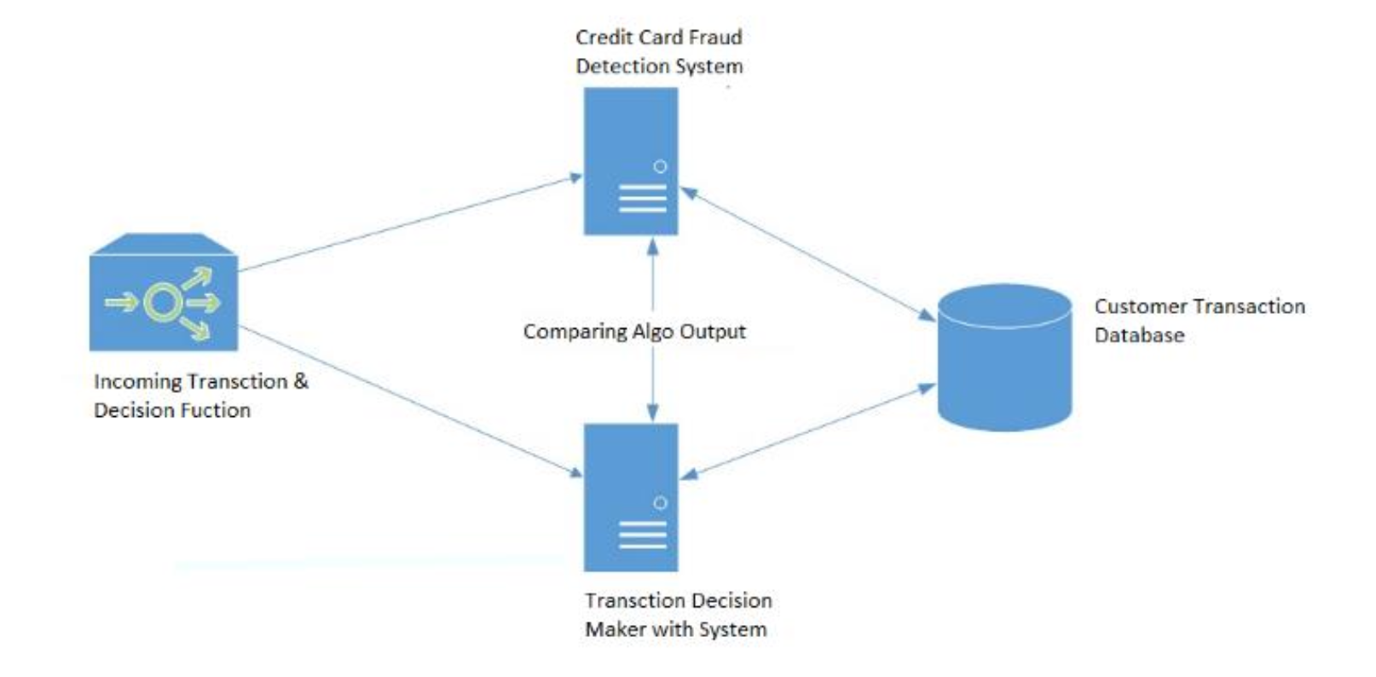

**Algorithms:**

**Logistic Regression:**

* Data Preparation:
  + Gather and pre-process the dataset, ensuring it is in a suitable format for logistic regression. Split the data into training and testing sets for model evaluation.
* Model Initialization:
  + Initialize the logistic regression model with random or zero weights.
* Training:
  + Iterate through the training data for a fixed number of epochs (iterations) or until convergence. For each training example, compute the weighted sum of the input features using the current model weights. Apply the logistic (sigmoid) function to the weighted sum to obtain a probability value between 0 and 1. Compare the predicted probability with the actual class label to calculate the prediction error (loss). Update the model weights using a technique like gradient descent to minimize the loss and improve predictions. Repeat the above steps for all training examples, adjusting the model weights after each iteration.
* Prediction:
  + Once the model is trained, use it to predict the class labels for unseen data. Compute the weighted sum of the input features using the learned model weights. Apply the logistic function to the weighted sum to obtain the predicted probability. Convert the probability into a binary prediction by applying a threshold (e.g., 0.5), classifying values above the threshold as one class and below as the other.
* Model Evaluation:
  + Evaluate the performance of the logistic regression model using appropriate metrics such as accuracy, precision, recall, and F1 score. Compare the predicted class labels with the actual class labels from the testing set.
* Model Optimization:
  + Fine-tune the logistic regression model by adjusting hyperparameters like learning rate, regularization, and convergence criteria. Perform feature selection or engineering techniques to improve model performance if necessary.
* Deployment:
  + Once satisfied with the model's performance, deploy it for real-time predictions on new, unseen data.

**SVM:**

* Input:
  + Gather and pre-process the dataset, ensuring it is in a suitable format for SVM. Encode categorical variables and normalize numerical features if necessary.
* Feature Selection:
  + If the dataset has high dimensionality, consider performing feature selection or dimensionality reduction techniques to improve efficiency and reduce noise.
* Training Data Preparation:
  + Split the dataset into training and testing sets for model evaluation. Ensure that the classes in the training set are balanced or use appropriate techniques for handling imbalanced data if needed.
* Model Initialization:
  + Select an appropriate kernel function (e.g., linear, polynomial, radial basis function) based on the problem's characteristics. Initialize the SVM model with the chosen kernel and other hyperparameters.
* Model Training:
  + Train the SVM model on the training set. The goal of SVM is to find an optimal hyperplane that separates the two classes with the maximum margin while minimizing classification errors. Depending on the kernel chosen, the training process may involve solving a quadratic optimization problem using techniques like Sequential Minimal Optimization (SMO) or interior point methods. The SVM algorithm learns the support vectors, which are the data points closest to the decision boundary and are crucial for classification.
* Model Evaluation:
  + Assess the performance of the trained SVM model using appropriate evaluation metrics such as accuracy, precision, recall, F1 score, or ROC curve. Evaluate the model's generalization ability by predicting the class labels of the testing set and comparing them to the ground truth.
* Hyperparameter Tuning:
  + Fine-tune the SVM model by adjusting hyperparameters such as the regularization parameter (C), the kernel-specific parameters (e.g., degree, gamma), and the margin-related parameters (e.g., epsilon, tolerance). Use techniques like grid search or random search combined with cross-validation to find the optimal hyperparameters that maximize performance.
* Prediction:
  + Once satisfied with the performance of the SVM model, use it to make predictions on new, unseen data. Pre-process the new data in the same manner as the training data, ensuring consistency in feature encoding and normalization.

**KNN:**

* Input:
  + Gather and pre-process the dataset, ensuring it is in a suitable format for KNN. Encode categorical variables and normalize numerical features if necessary.
* Feature Selection:
  + If the dataset has high dimensionality, consider performing feature selection or dimensionality reduction techniques to improve efficiency and reduce noise.
* Training Data Preparation:
  + Split the dataset into training and testing sets for model evaluation. Determine the value of K, the number of nearest neighbors to consider for classification.
* Model Training:
  + KNN is a lazy learning algorithm, meaning there is no explicit training phase. Instead, the model memorizes the training data for later use during prediction.
* Prediction:
  + For each instance in the testing set, calculate its distance (e.g., Euclidean distance, Manhattan distance) to all instances in the training set. Select the K nearest neighbours based on the calculated distances. For classification, determine the majority class label among the K nearest neighbours. For regression, calculate the average or weighted average of the K nearest neighbours’ target values. Assign the predicted class label or regression value to the test instance.
* Model Evaluation:
  + Assess the performance of the KNN model using appropriate evaluation metrics such as accuracy, precision, recall, F1 score, or mean squared error (MSE) for regression tasks. Compare the predicted class labels or regression values with the ground truth from the testing set.
* Hyperparameter Tuning:
  + Fine-tune the KNN model by adjusting hyperparameters such as the value of K. Use techniques like grid search or cross-validation to find the optimal value of K that maximizes performance.
* Prediction on New Data:
  + Once satisfied with the performance of the KNN model, use it to make predictions on new, unseen data. Preprocess the new data in the same manner as the training data, ensuring consistency in feature encoding and normalization.

**Decision Tree:**

* Input:
  + Gather and pre-process the dataset, ensuring it is in a suitable format for Decision Tree. Encode categorical variables and normalize numerical features if necessary.
* Feature Selection:
  + If the dataset has high dimensionality, consider performing feature selection or dimensionality reduction techniques to improve efficiency and reduce noise.
* Training Data Preparation:
  + Split the dataset into training and testing sets for model evaluation.
* Model Training:
  + Initialize the Decision Tree model. Select an appropriate criterion for splitting the nodes, such as Gini impurity or information gain. Recursively build the Decision Tree by selecting the best split at each node based on the chosen criterion. Determine the stopping criteria for tree construction, such as maximum depth, minimum number of samples per leaf, or minimum impurity decrease. Continue splitting the nodes until the stopping criteria are met or no further improvement is possible.
* Prediction:
  + Once the Decision Tree is built, use it to make predictions on new, unseen data. Traverse the tree from the root node to a leaf node by following the appropriate decision based on the feature values. Assign the majority class label of the training instances in the leaf node for classification tasks.
* Model Evaluation:
  + Assess the performance of the Decision Tree model using appropriate evaluation metrics such as accuracy, precision, recall, F1 score, or mean squared error (MSE) for regression tasks. Compare the predicted class labels or regression values with the ground truth from the testing set.
* Pruning:
  + Optionally, perform pruning techniques such as pre-pruning or post-pruning to avoid overfitting. Pre-pruning involves setting constraints on tree construction (e.g., maximum depth, minimum samples per leaf) to prevent excessive growth. Post-pruning involves removing or merging nodes from the fully grown tree based on their estimated impact on the overall performance.
* Hyperparameter Tuning:
  + Fine-tune the Decision Tree model by adjusting hyperparameters such as the splitting criterion, maximum depth, or minimum samples per leaf. Use techniques like grid search or random search combined with cross-validation to find the optimal hyperparameters that maximize performance.
* Prediction on New Data:
  + Once satisfied with the performance of the Decision Tree model, use it to make predictions on new, unseen data. Pre-process the new data in the same manner as the training data, ensuring consistency in feature encoding and normalization.

**SMOTE:**

* Input:
  + Obtain the imbalanced dataset with the minority and majority classes.
* Identifying Minority Class:
  + Identify the minority class samples in the dataset.
* Nearest Neighbour Selection:
  + For each minority class sample, find its k nearest neighbours in the feature space. The value of k is a user-defined parameter.
* Synthetic Sample Generation:
  + For each minority class sample, randomly select one of its k nearest neighbours.
  + Compute the difference between the feature values of the selected neighbour and the current minority sample.
  + Multiply this difference by a random value between 0 and 1.
  + Add the resulting difference to the current minority sample to generate a new synthetic sample.
  + Repeat the above steps to generate a desired number of synthetic samples.
* Dataset Balancing:
  + Combine the original minority class samples with the generated synthetic samples to form a balanced dataset.
* Model Training and Evaluation:
  + Split the balanced dataset into training and testing sets.
  + Train a classification model (e.g., logistic regression, decision tree, etc.) on the training set using the balanced dataset.
  + Evaluate the trained model on the testing set to assess its performance.
* Output:
  + The final output is a balanced dataset with synthetic samples included.

**SMOTEEN:**

* Input:
  + Obtain the imbalanced dataset with the minority and majority classes.
* Identifying Minority Class:
  + Identify the minority class samples in the dataset. Nearest
* Neighbour Selection (SMOTE):
  + For each minority class sample, find its k nearest neighbors in the feature space using the SMOTE algorithm.
* Synthetic Sample Generation (SMOTE):
  + For each minority class sample, randomly select one of its k nearest neighbours.
  + Compute the difference between the feature values of the selected neighbour and the current minority sample.
  + Multiply this difference by a random value between 0 and 1.
  + Add the resulting difference to the current minority sample to generate a new synthetic sample.
  + Repeat the above steps to generate a desired number of synthetic samples.
* Dataset Balancing:
  + Combine the original minority class samples with the generated synthetic samples to form an intermediate balanced dataset.
* Noisy Sample Removal (ENN):
  + For each sample in the intermediate balanced dataset, apply the ENN algorithm. ENN removes samples whose class label differs from the majority of their k nearest neighbours.
* Combine Cleaned Data:
  + Combine the remaining samples from the intermediate balanced dataset after the ENN step with the majority class samples.
* Model Training and Evaluation:
  + Split the cleaned dataset into training and testing sets.
  + Train a classification model (e.g., logistic regression, decision tree, etc.) on the training set using the cleaned dataset.
  + Evaluate the trained model on the testing set to assess its performance.
* Output:
  + The final output is a balanced and cleaned dataset, ready for model training and evaluation.

**Code and Output:**

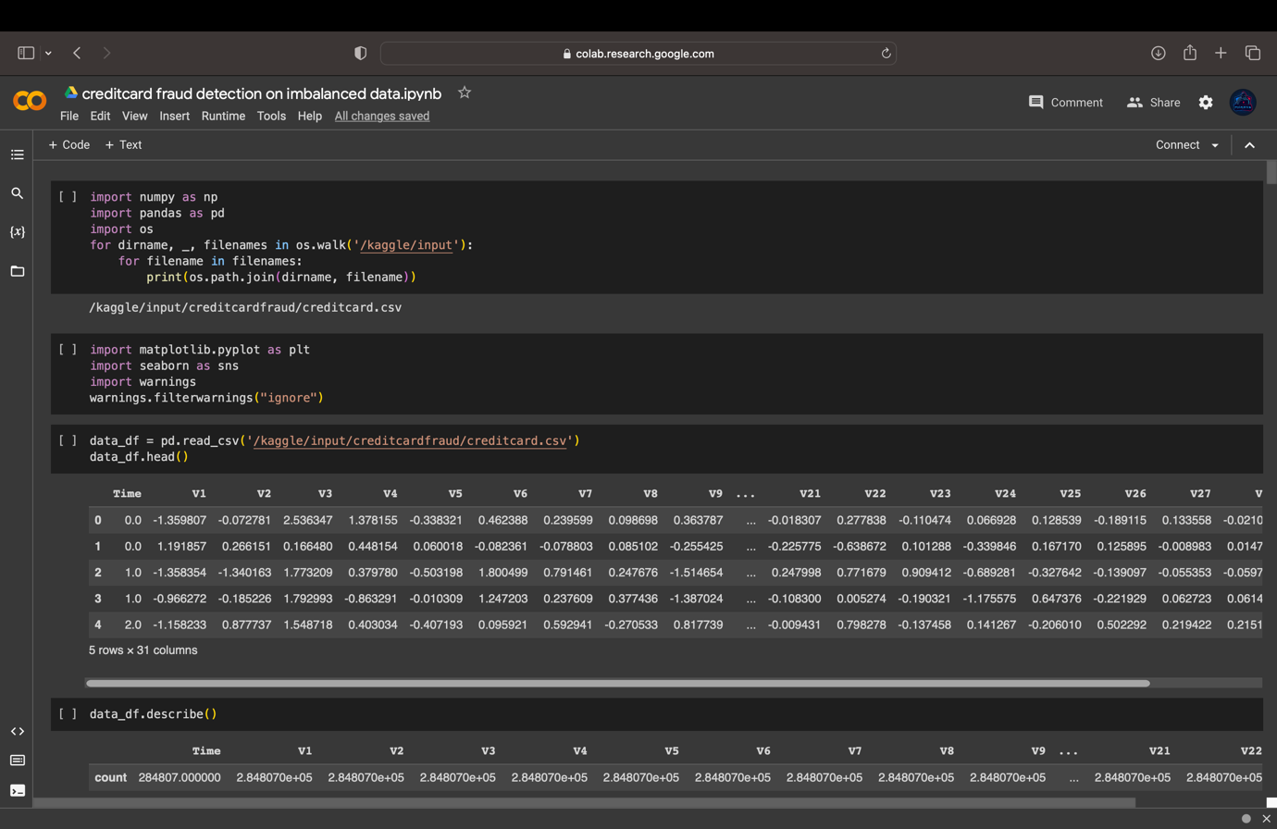

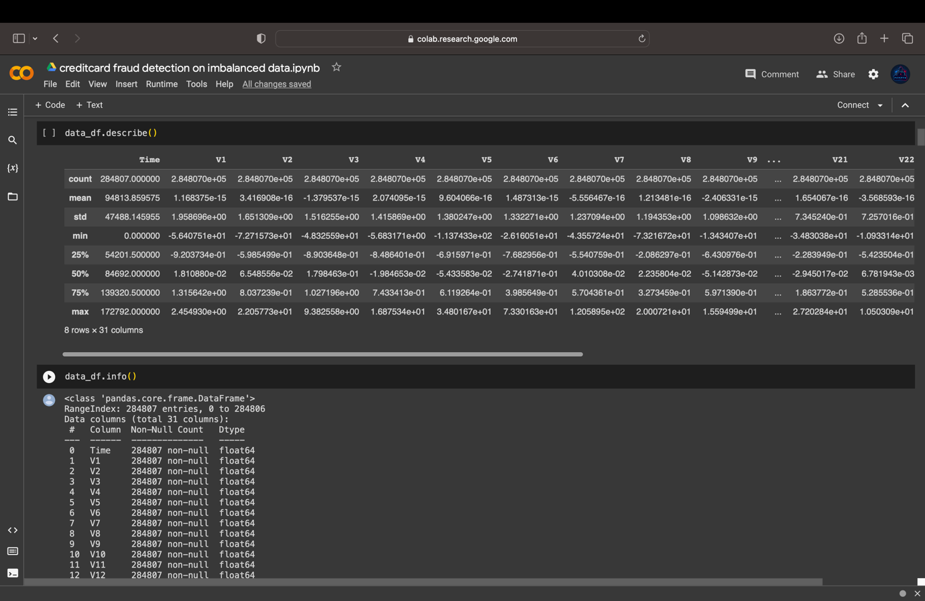

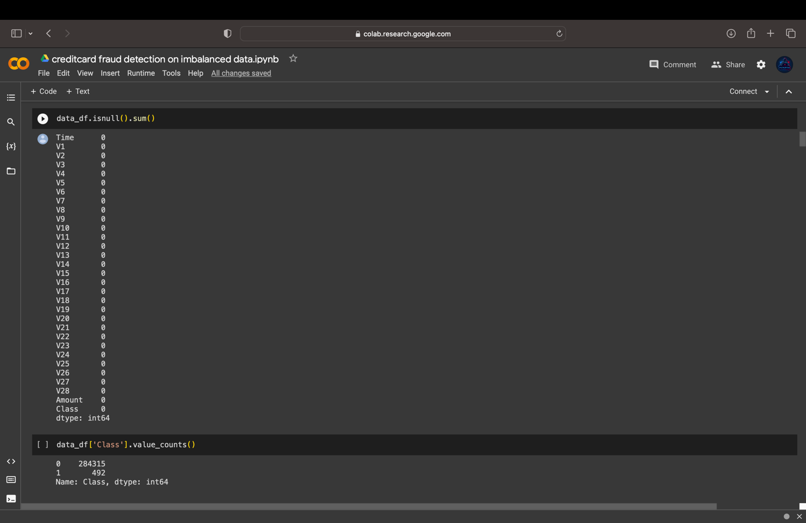

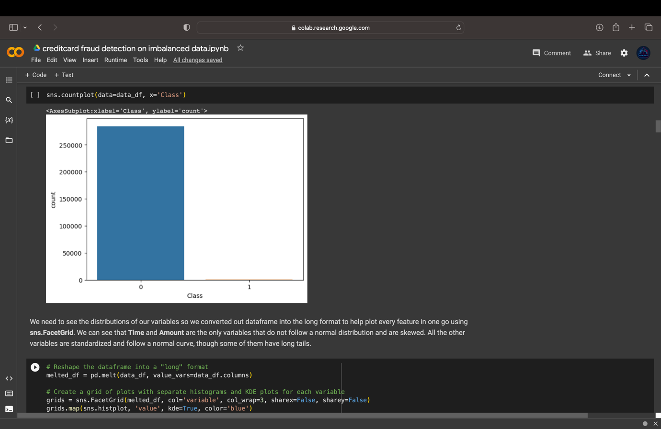

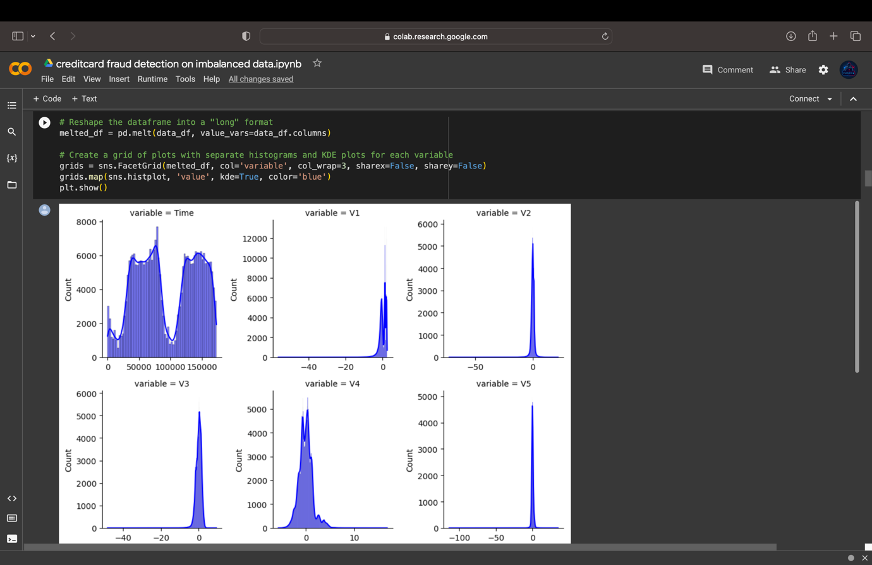

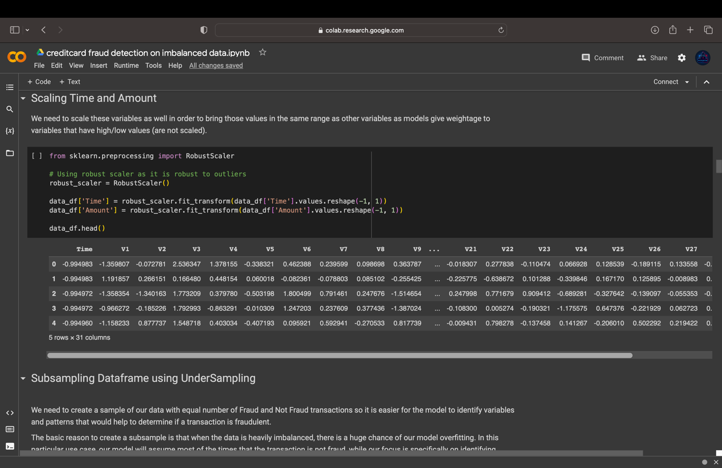

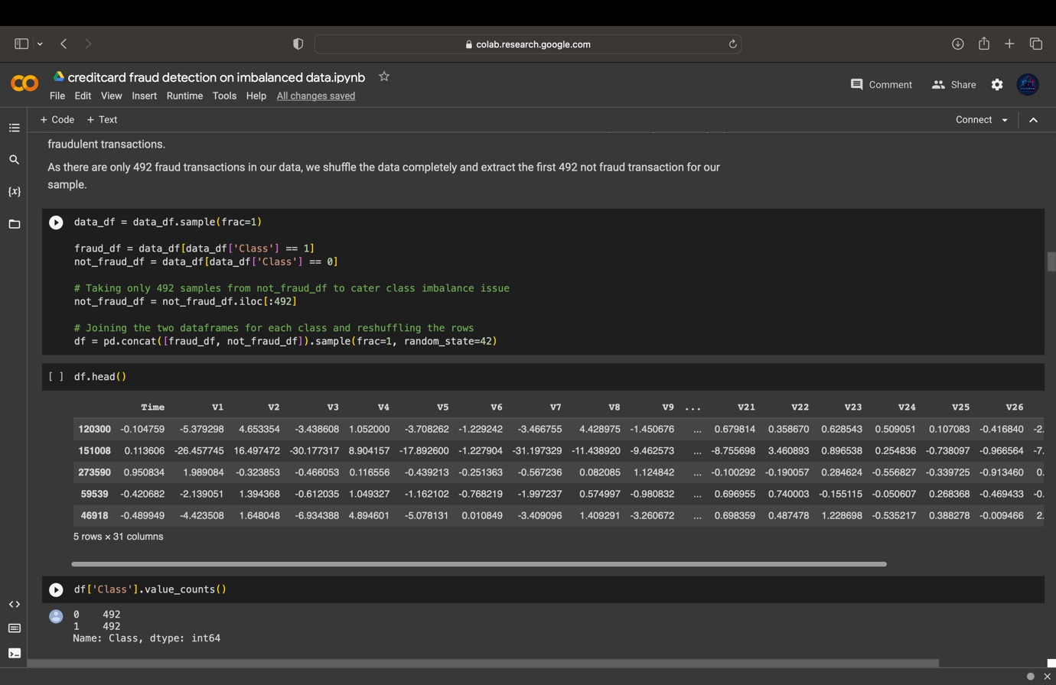



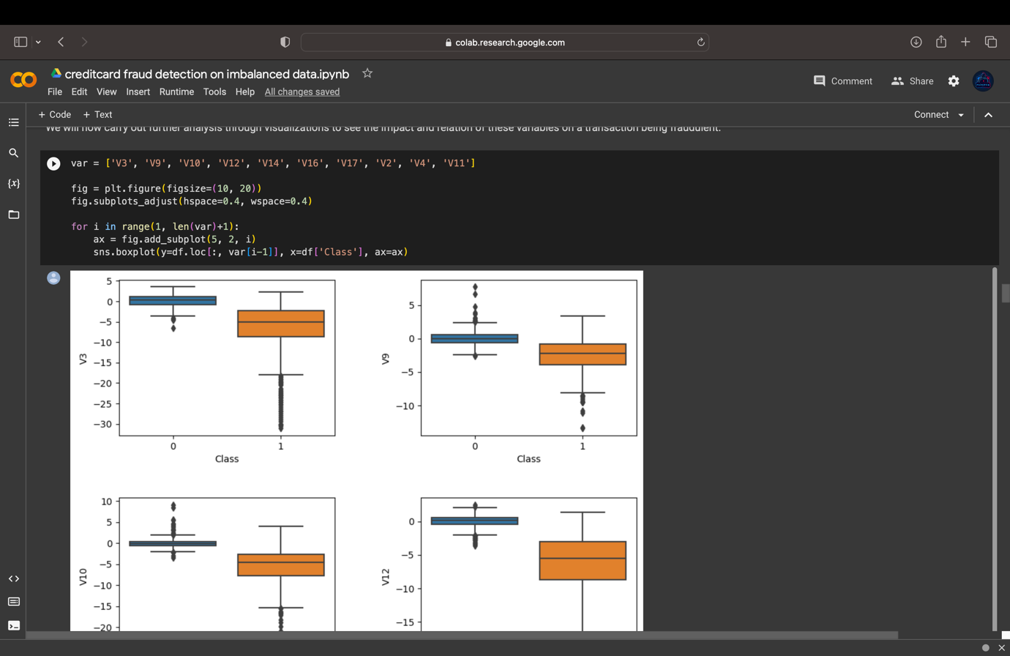

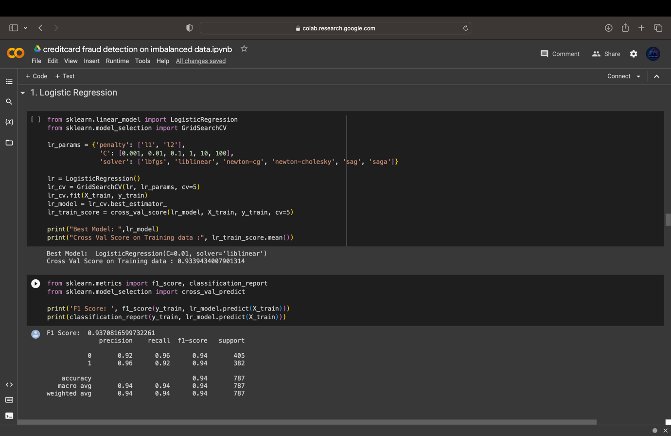

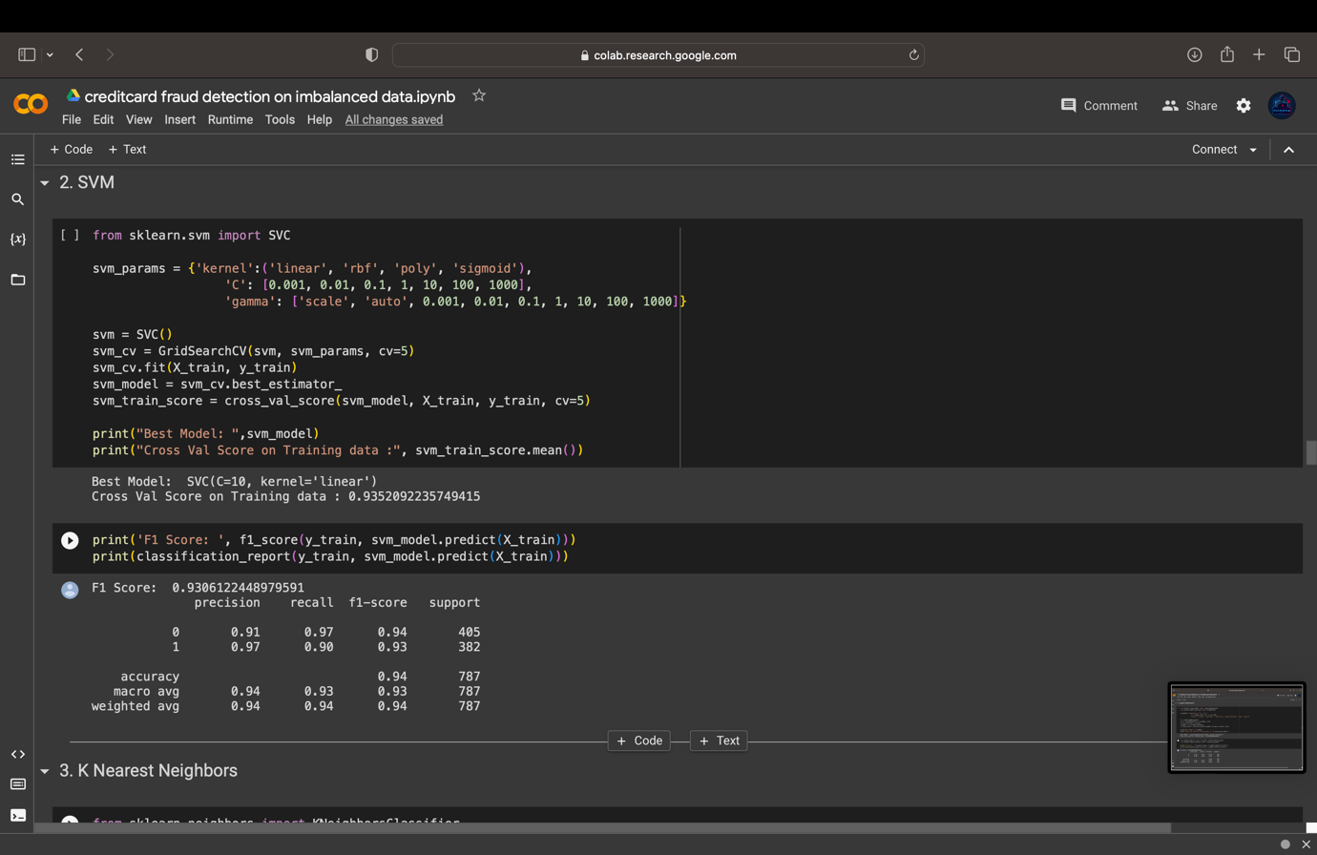

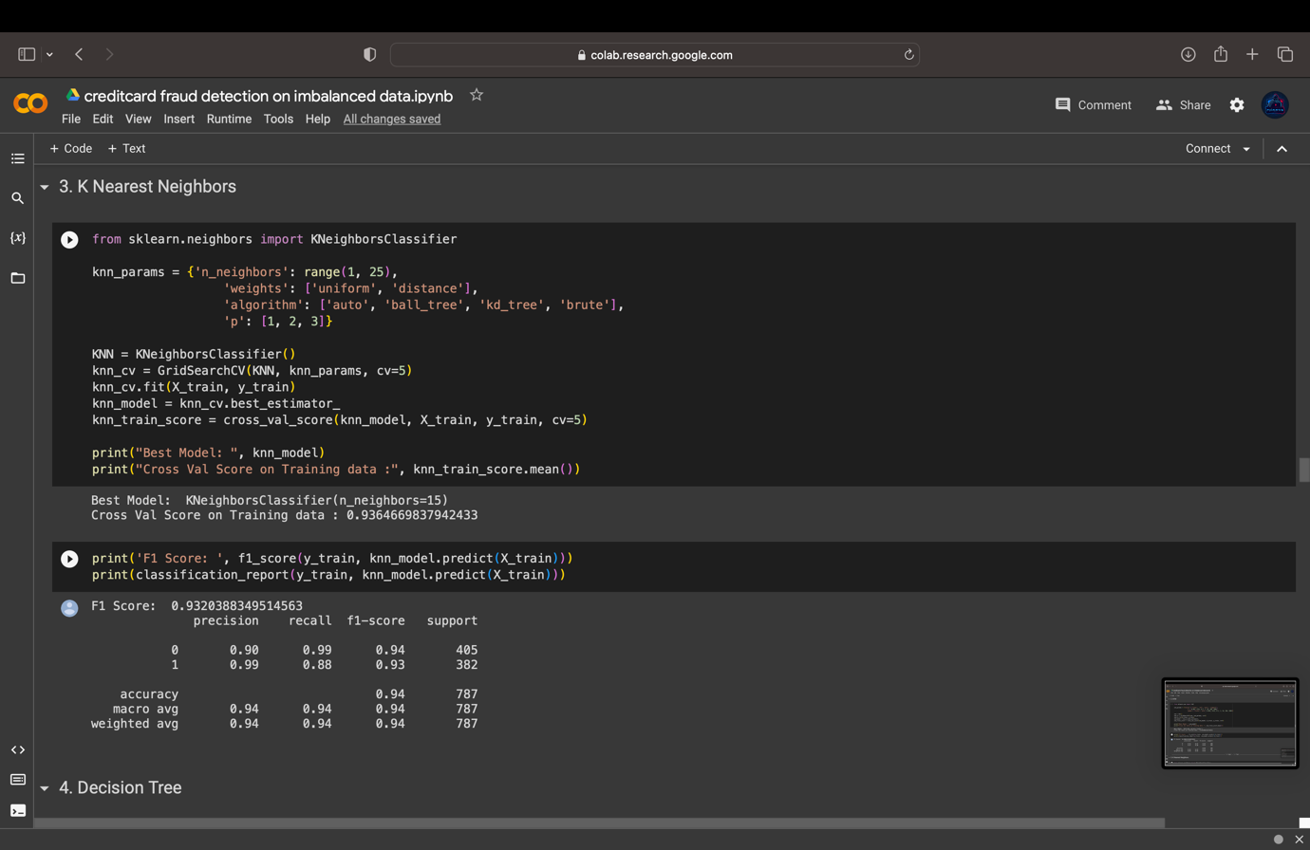

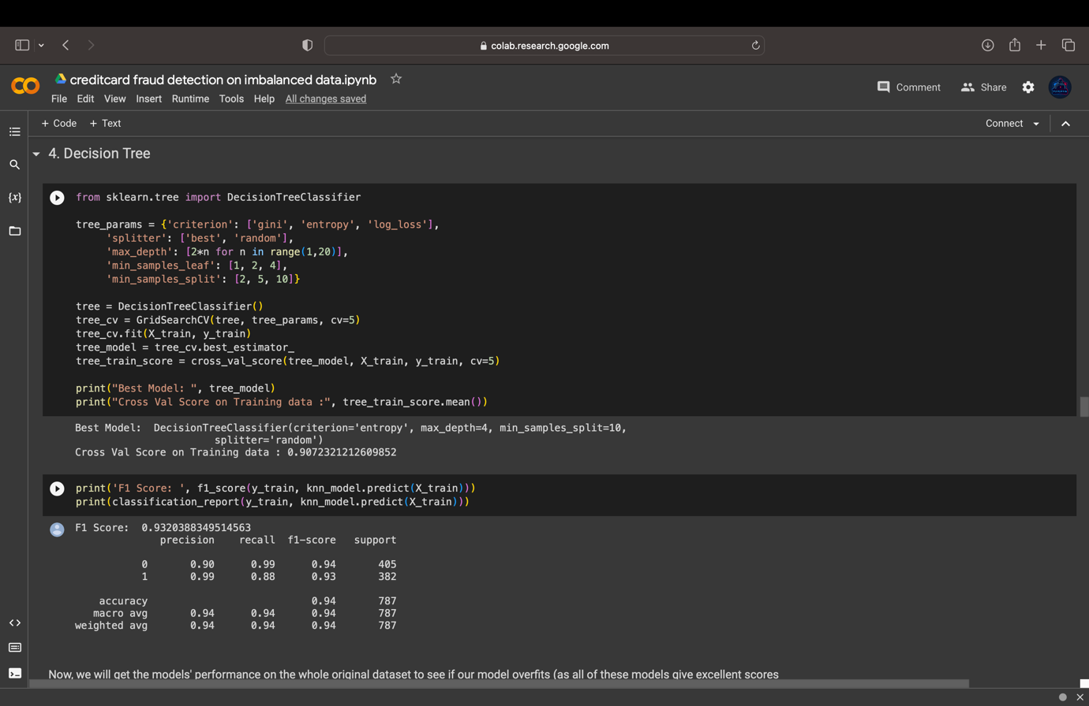

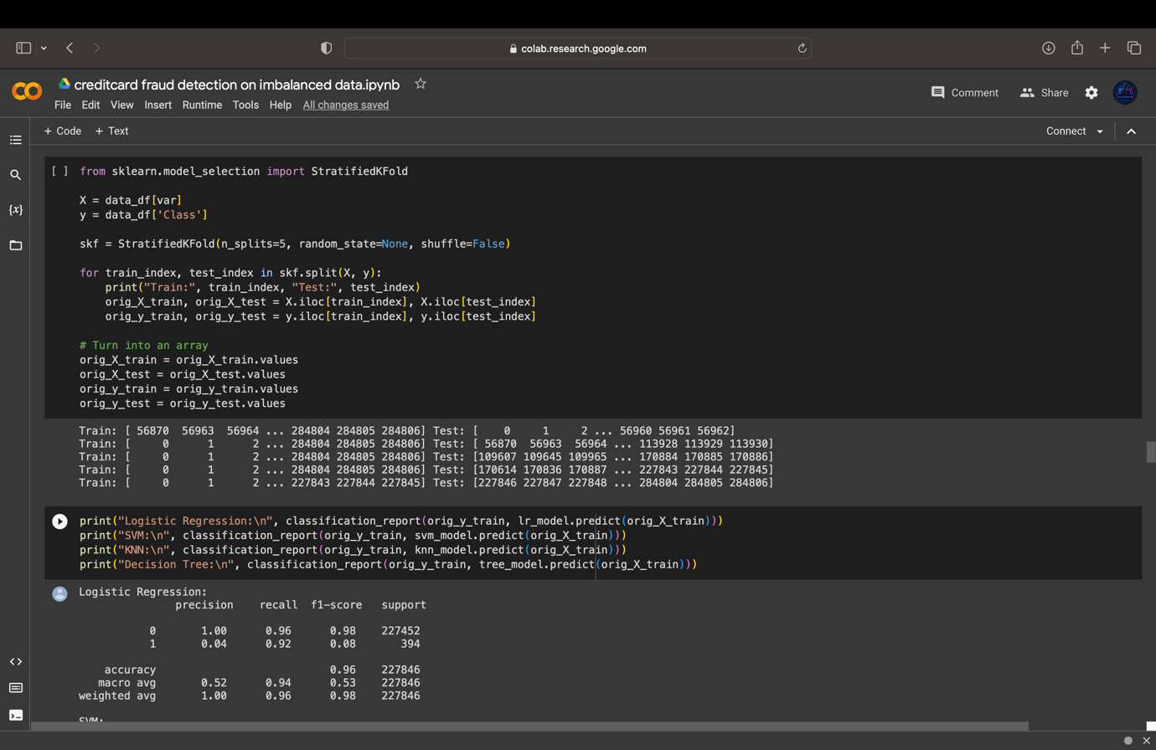

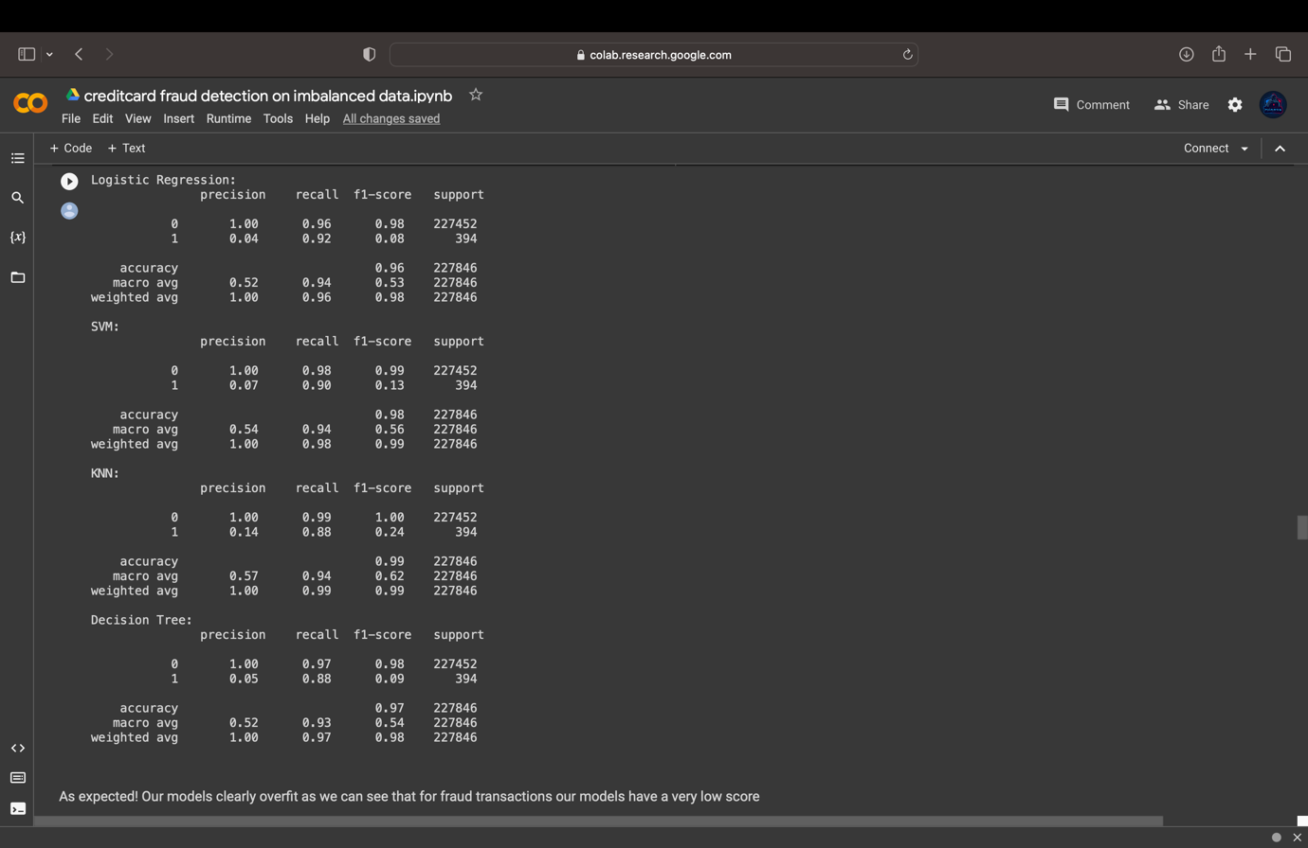

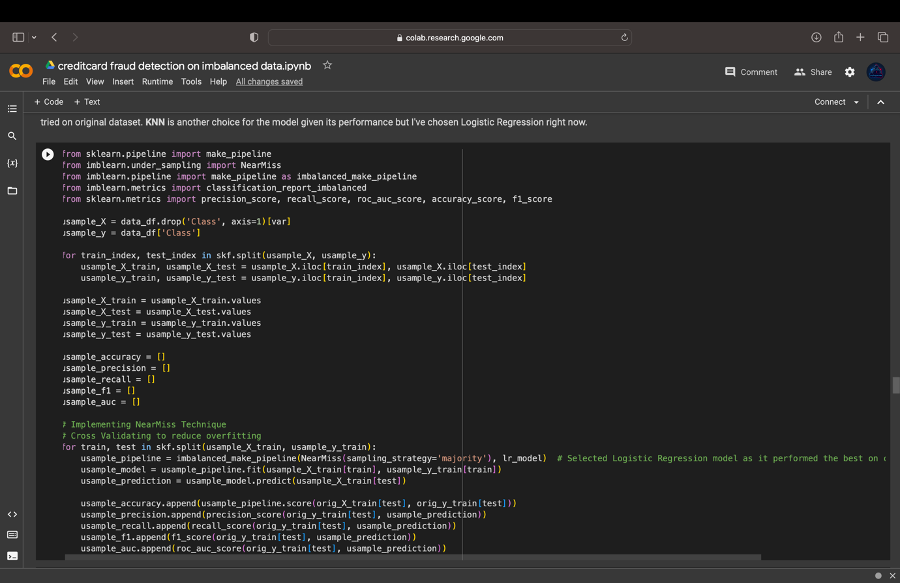

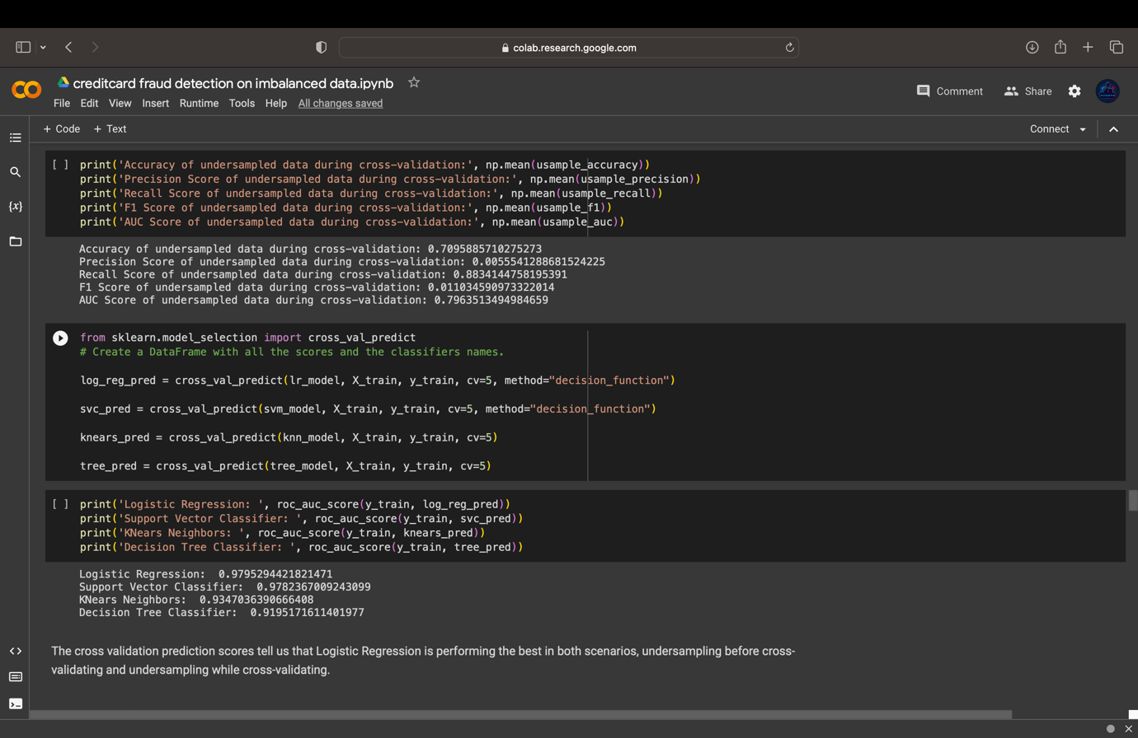

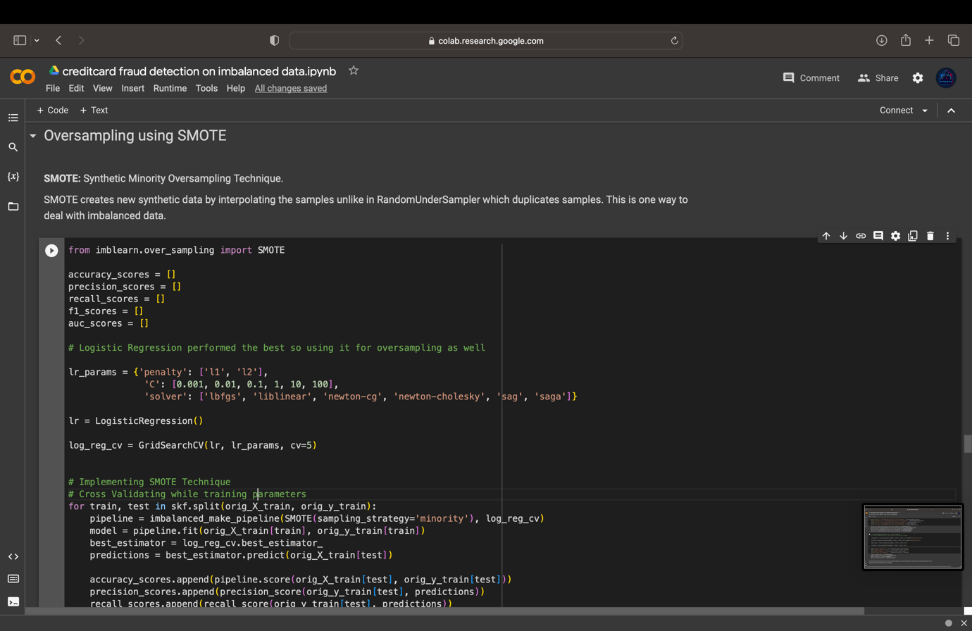

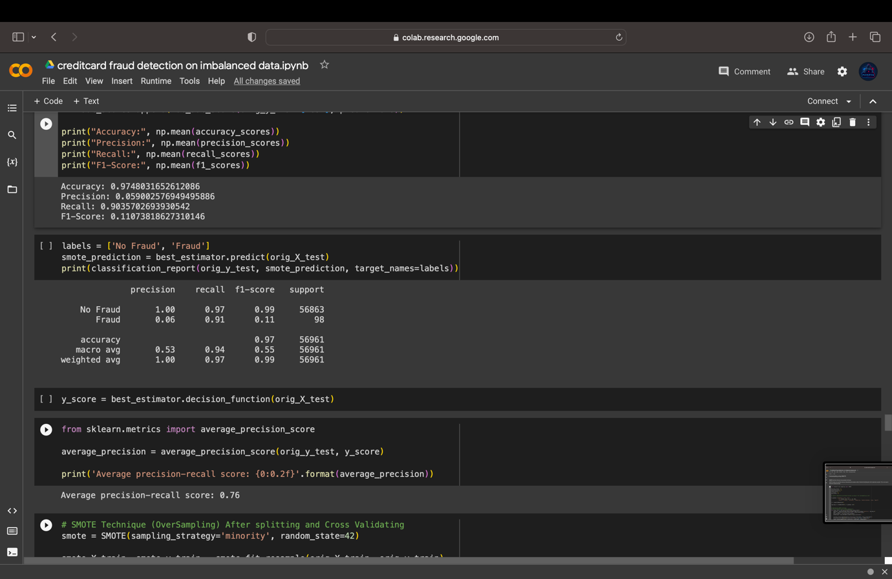

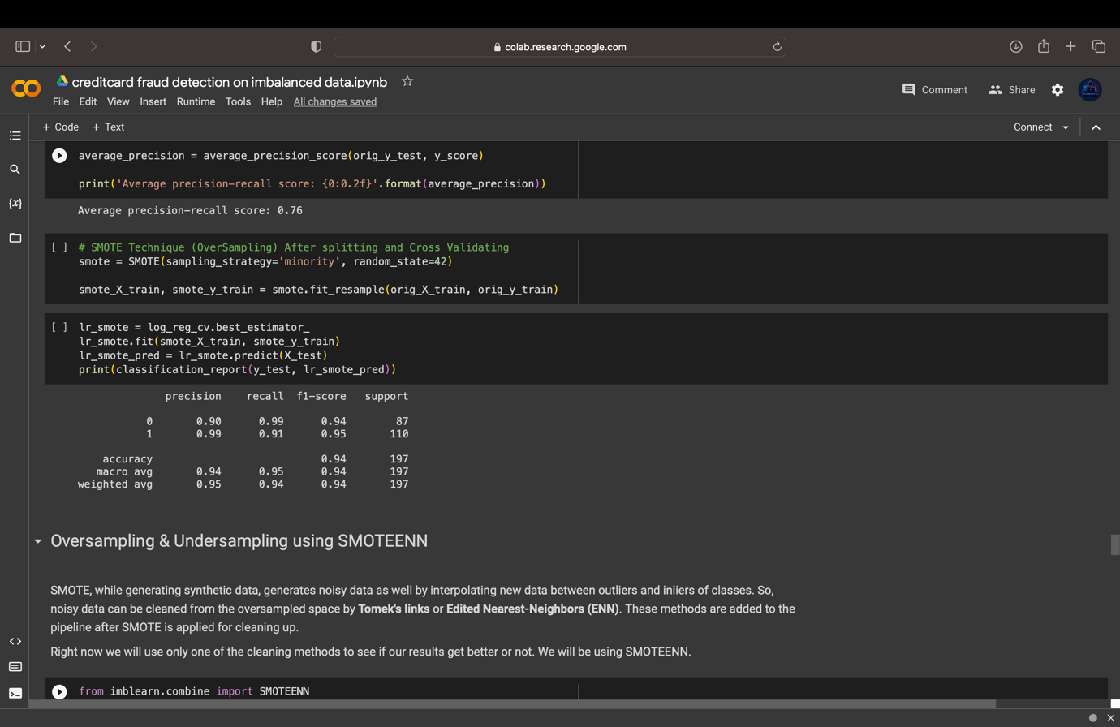

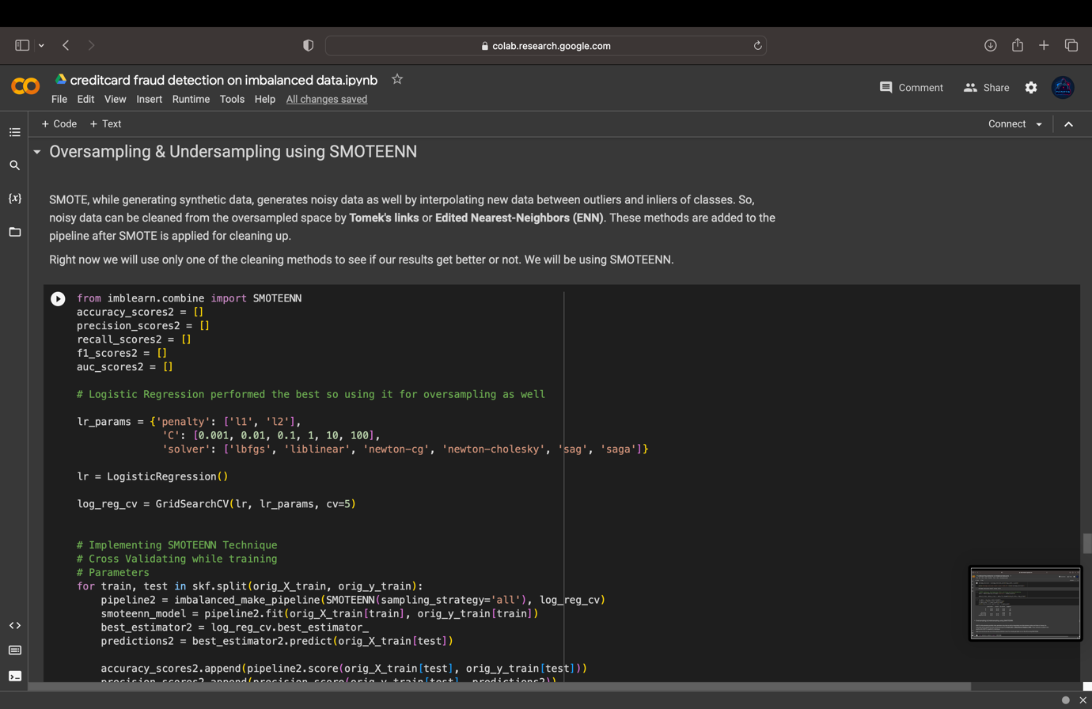

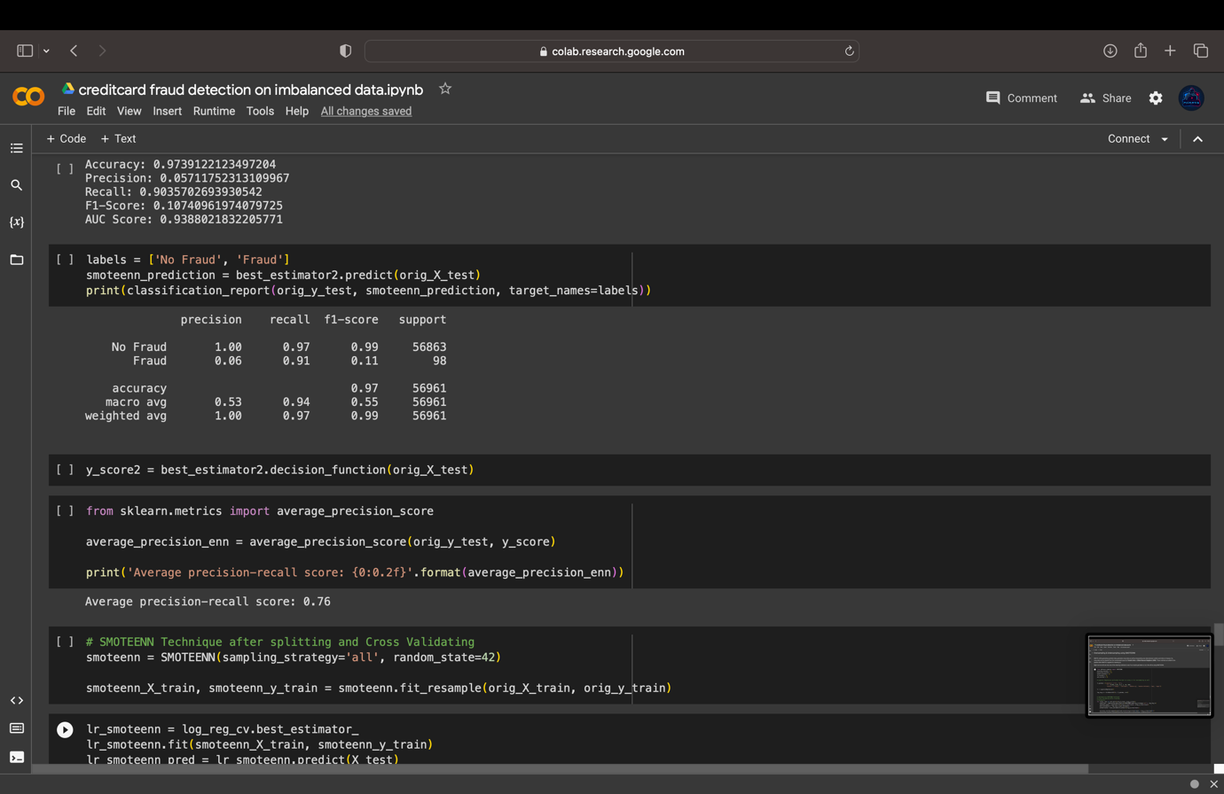

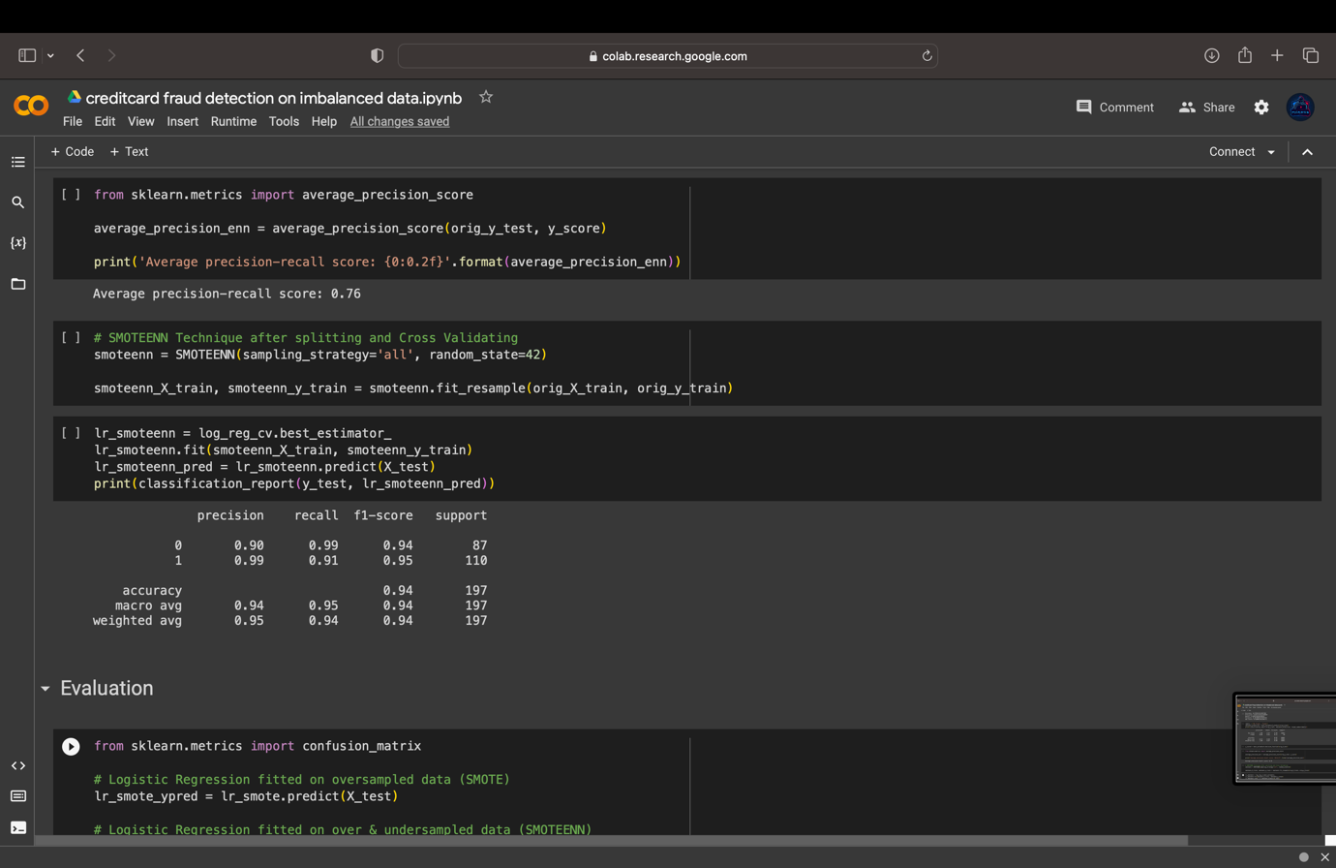

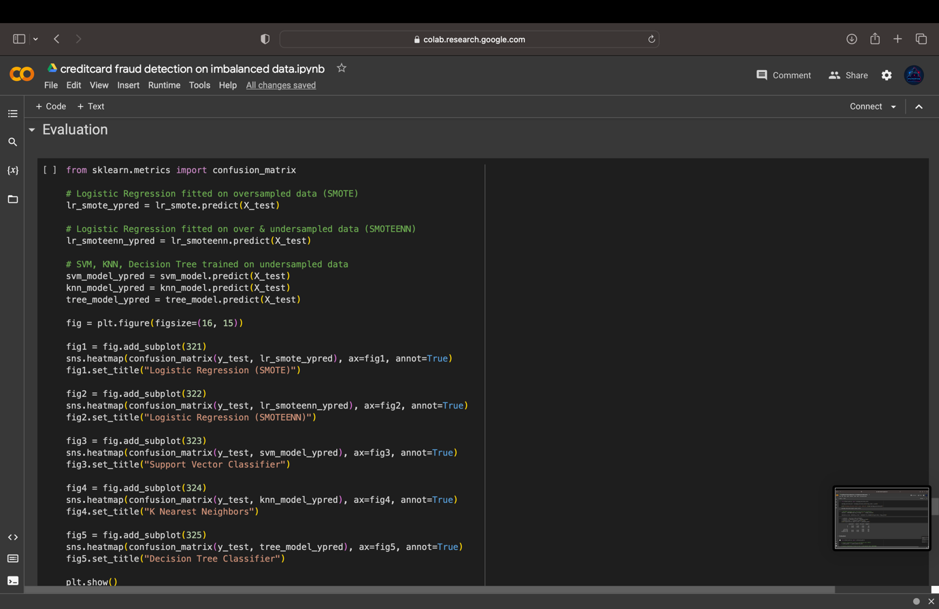

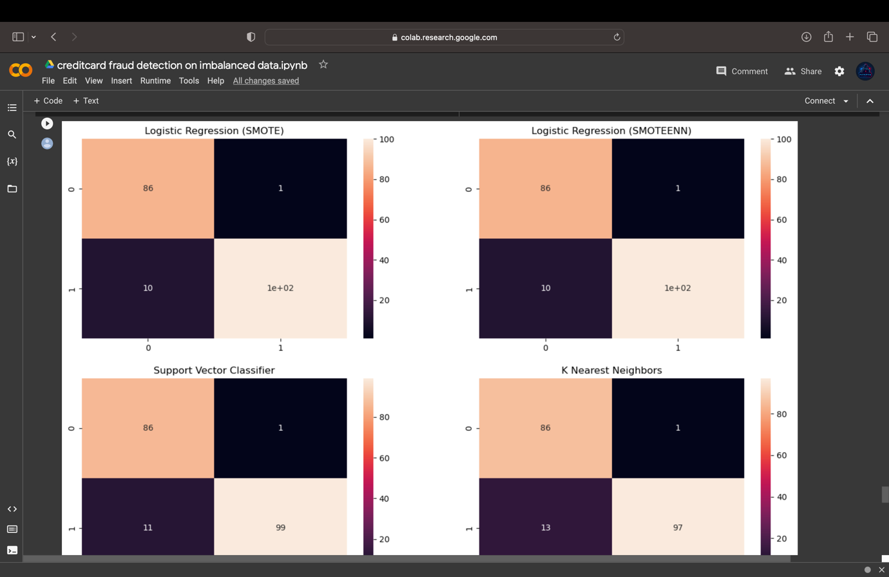



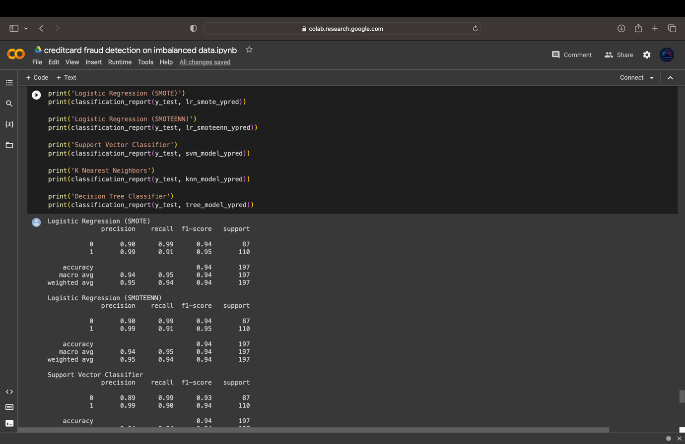

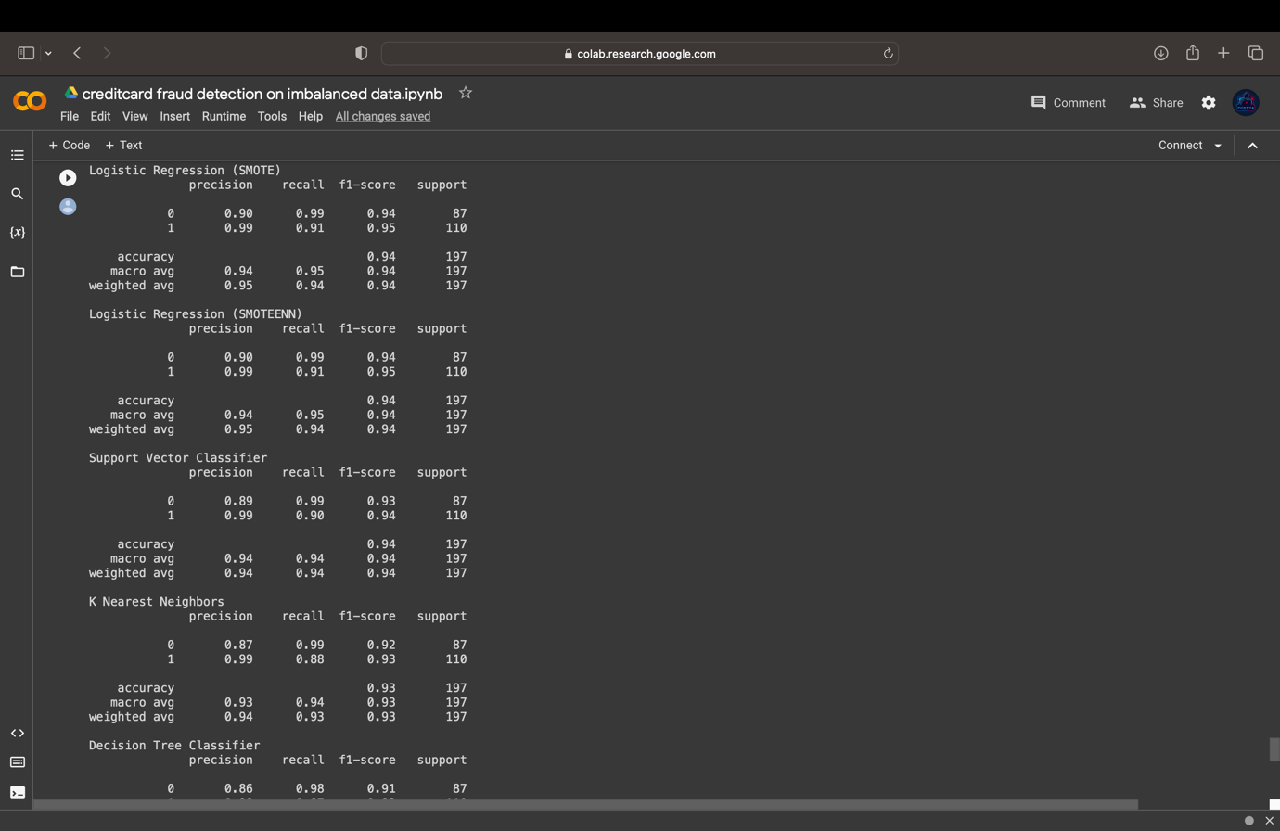

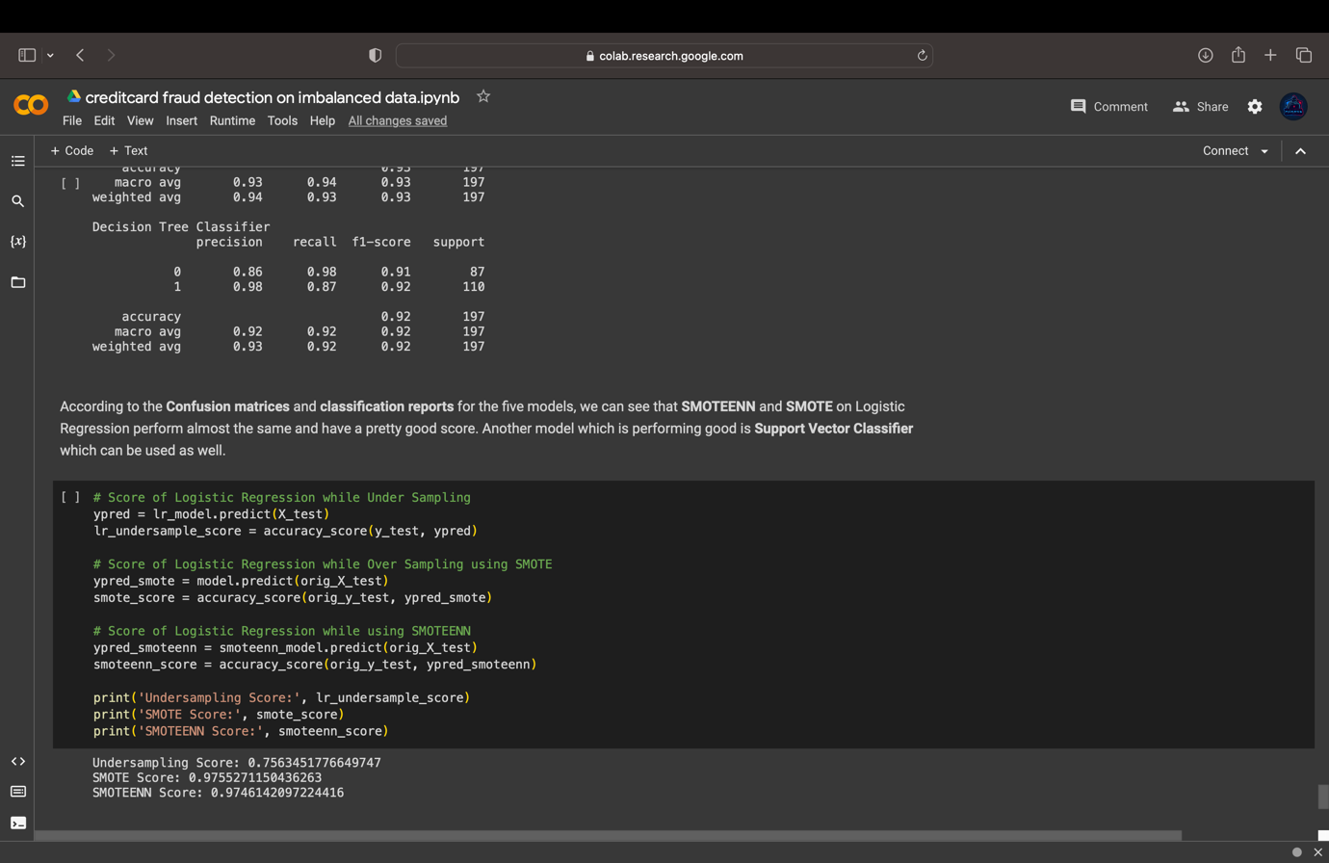

**Conclusion:**

Credit card fraud detection on imbalanced data presents a complex and challenging task for financial institutions and data scientists alike. In this document, we have explored the various challenges associated with imbalanced data and discussed several techniques and methodologies proposed to address these challenges.

Imbalanced data distribution, where fraudulent transactions are relatively rare compared to legitimate transactions, hampers the performance of traditional machine learning algorithms. However, through the use of oversampling techniques such as SMOTE, synthetic instances of fraud can be generated to balance the dataset. Undersampling methods can also be employed to selectively reduce the majority class, maintaining a proportionate representation of fraudulent cases. Additionally, ensemble learning methods and deep learning approaches have shown promise in improving the accuracy of fraud detection by leveraging the strengths of multiple classifiers and capturing intricate patterns in the data.

It is crucial to emphasize that credit card fraud detection is an ongoing battle, as fraudsters continuously evolve their techniques. Therefore, the proposed methodologies should be implemented in real-time systems that are continuously monitored and updated. Regular evaluations of the detection system's performance are essential to ensure its effectiveness and to adapt to emerging fraud patterns.

While significant progress has been made in credit card fraud detection on imbalanced data, there is still room for improvement. Future research should focus on exploring advanced techniques such as hybrid sampling methods, incorporating domain-specific knowledge, and leveraging emerging technologies like explainable artificial intelligence to enhance interpretability and trust in the detection models.

Implementing SMOTE and SMOTEENN significantly increased the performance of the selected model when our data was highly imbalanced. Without implementing any balancing technique, our models were highly overfitted with very bad scores for detecting fraud transactions. This shows that balancing the classes by using any approach is necessary when dealing with imbalanced data. The first approach we used was undersampling where the performance increased but it was still misclassifying non-fraudulent transactions as fraudulent. This would surely increase dissatisfaction among the users if their normal transactions are reported as fraudulent and would certainly lead to a huge loss for the company. Therefore, we need to be careful to select the approach that would reduce both type of errors: Fraud transactions as non-fraudulent, and Not Fraud transactions as Fraudulent.

Ultimately, the effective detection of credit card fraud on imbalanced data is vital to mitigate financial losses, protect cardholders, and maintain the integrity of electronic payment systems. By continuously refining and advancing fraud detection techniques, we can stay one step ahead of fraudsters and contribute to a more secure and trustworthy financial landscape.

**References:**

1. [**https://www.researchgate.net/publication/342325695_Credit_Card_Fraud_Detection_Using_Machine_Learning**](https://www.researchgate.net/publication/342325695_Credit_Card_Fraud_Detection_Using_Machine_Learning)
2. [**https://www.researchgate.net/publication/365227850_Credit_Card_Fraud_Detection_Using_Various_Machine_Learning_and_Deep_Learning_Approaches**](https://www.researchgate.net/publication/365227850_Credit_Card_Fraud_Detection_Using_Various_Machine_Learning_and_Deep_Learning_Approaches)
3. [**http://www.ijstr.org/final-print/mar2020/Real-time-Deep-Learning-Based-Credit-Card-Fraud-Detection.pdf**](http://www.ijstr.org/final-print/mar2020/Real-time-Deep-Learning-Based-Credit-Card-Fraud-Detection.pdf)
4. [**https://ieeexplore.ieee.org/document/9776955**](https://ieeexplore.ieee.org/document/9776955)
5. [**https://www.google.com/url?sa=t&rct=j&q=&esrc=s&source=web&cd=&cad=rja&uact=8&ved=2ahUKEwiJmozoq8r_AhXqb2wGHT8DAxQQFnoECA8QAQ&url=https%3A%2F%2Fceur-ws.org%2FVol-3283%2FPaper127.pdf&usg=AOvVaw2vny0HPNmM-KkNR6D93GY5&opi=89978449**](https://www.google.com/url?sa=t&rct=j&q=&esrc=s&source=web&cd=&cad=rja&uact=8&ved=2ahUKEwiJmozoq8r_AhXqb2wGHT8DAxQQFnoECA8QAQ&url=https%3A%2F%2Fceur-ws.org%2FVol-3283%2FPaper127.pdf&usg=AOvVaw2vny0HPNmM-KkNR6D93GY5&opi=89978449)
6. [**https://www.obviously.ai/post/credit-card-fraud-detection-with-machine-learning**](https://www.obviously.ai/post/credit-card-fraud-detection-with-machine-learning)
7. [**https://www.researchgate.net/publication/341882788_CREDIT_CARD_FRAUD_DETECTOR_USING_ARTIFICIAL_INTELLIGENCE**](https://www.researchgate.net/publication/341882788_CREDIT_CARD_FRAUD_DETECTOR_USING_ARTIFICIAL_INTELLIGENCE)
8. [**https://journalofbigdata.springeropen.com/articles/10.1186/s40537-022-00573-8**](https://journalofbigdata.springeropen.com/articles/10.1186/s40537-022-00573-8)
9. [**https://www.researchgate.net/publication/336800562_Credit_Card_Fraud_Detection_using_Machine_Learning_and_Data_Science**](https://www.researchgate.net/publication/336800562_Credit_Card_Fraud_Detection_using_Machine_Learning_and_Data_Science)
10. [**https://scholarworks.rit.edu/cgi/viewcontent.cgi?article=12455&context=theses**](https://scholarworks.rit.edu/cgi/viewcontent.cgi?article=12455&context=theses)
11. [**http://dspace.srmist.edu.in/jspui/bitstream/123456789/35113/1/P10088.pdf**](http://dspace.srmist.edu.in/jspui/bitstream/123456789/35113/1/P10088.pdf)
12. [**https://ijcsmc.com/docs/papers/April2021/V10I4202112.pdf**](https://ijcsmc.com/docs/papers/April2021/V10I4202112.pdf)

**Project Link:**

[**https://colab.research.google.com/drive/1Vo80MLzmg0t8De37oEUtZrLTt6dEa8yr?usp=sharing**](https://colab.research.google.com/drive/1Vo80MLzmg0t8De37oEUtZrLTt6dEa8yr?usp=sharing)